SUPER MARIO GAME DEPLOYMENT

(AWS DEVOPS PROJECT)

Prerequisite →

1. We will use AWS account .
2. Then we configure Terraform inside an ec2 instance
3. we also need an IAM ec2 role that provide necessary permission to ec2

Completion steps →

Step 1 → Login and basics setup

Step 2 → Setup Docker ,Terraform ,aws cli , and Kubectl

Step 3 → IAM Role for EC2

Step 4 →Attach IAM role with your EC2

Step 5 → Building Infrastructure Using terraform

Step 6 → Creation of deployment and service for EKS

Step 7 → Destroy all the Insrastructure

Steps:

Step 1 : First we will Launch EC2 machine

Go to aws account

Go to Instances ->Launch instance

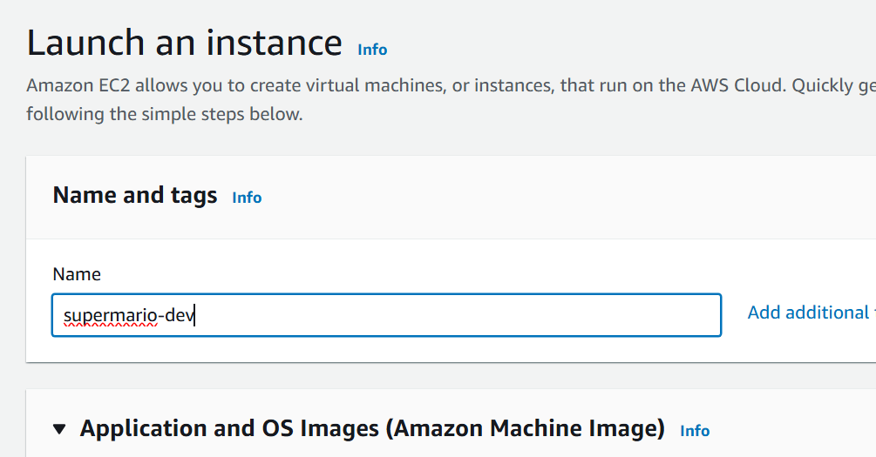

Use AMI as ubuntu

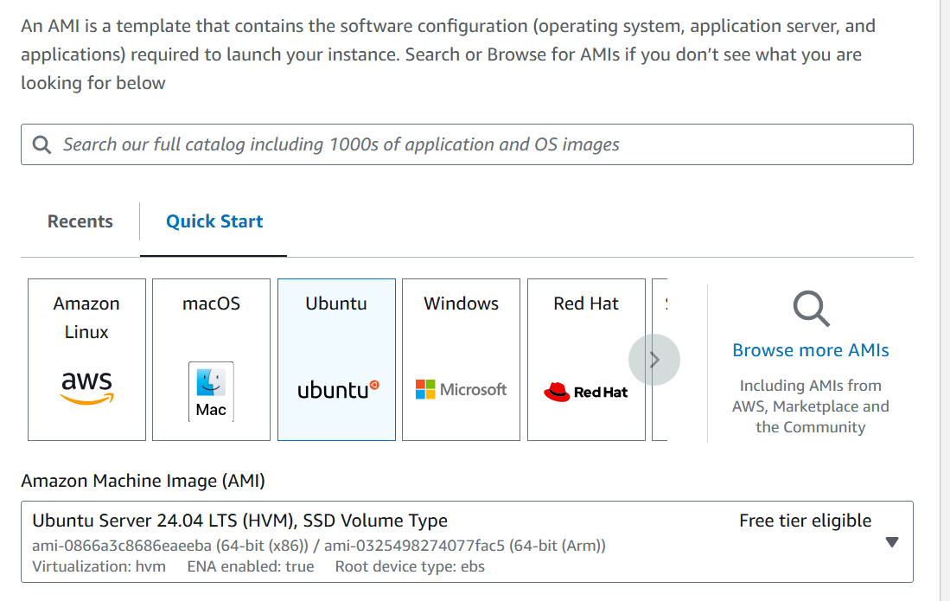

Instance type : T3.medium

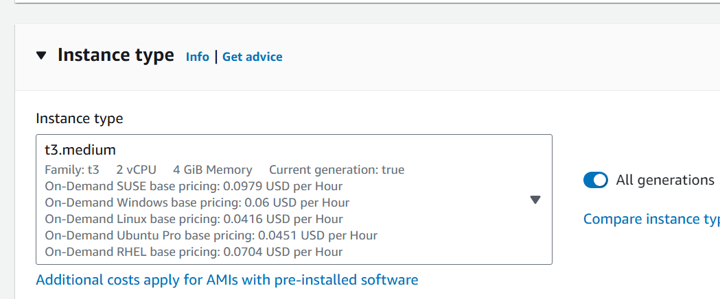

Create a new key pair

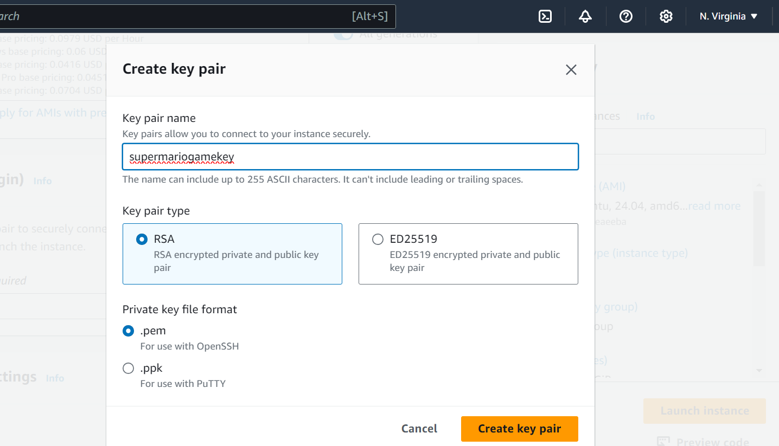

In security group allow ssh and http traffic

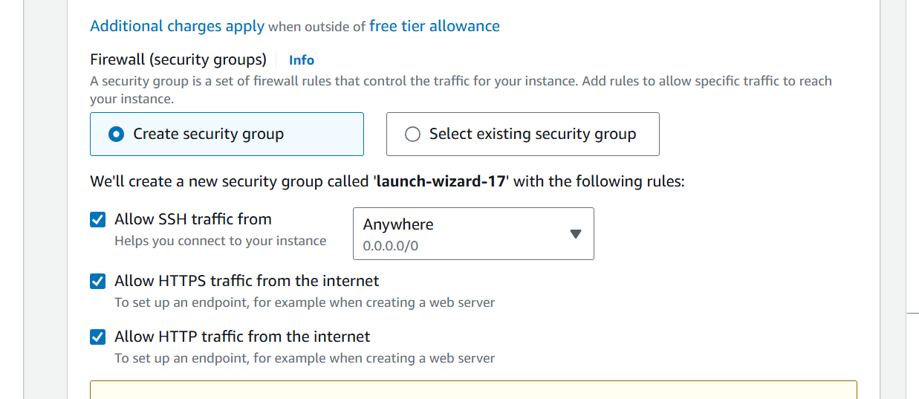

Go ahead and launch the instance

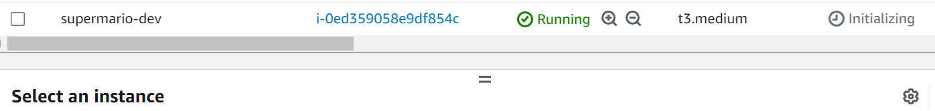

2) Now we will connect to the machine . For that we will first select the machine

And then click on connect button

Click on Ec2 instance connect tab

And click on connect button

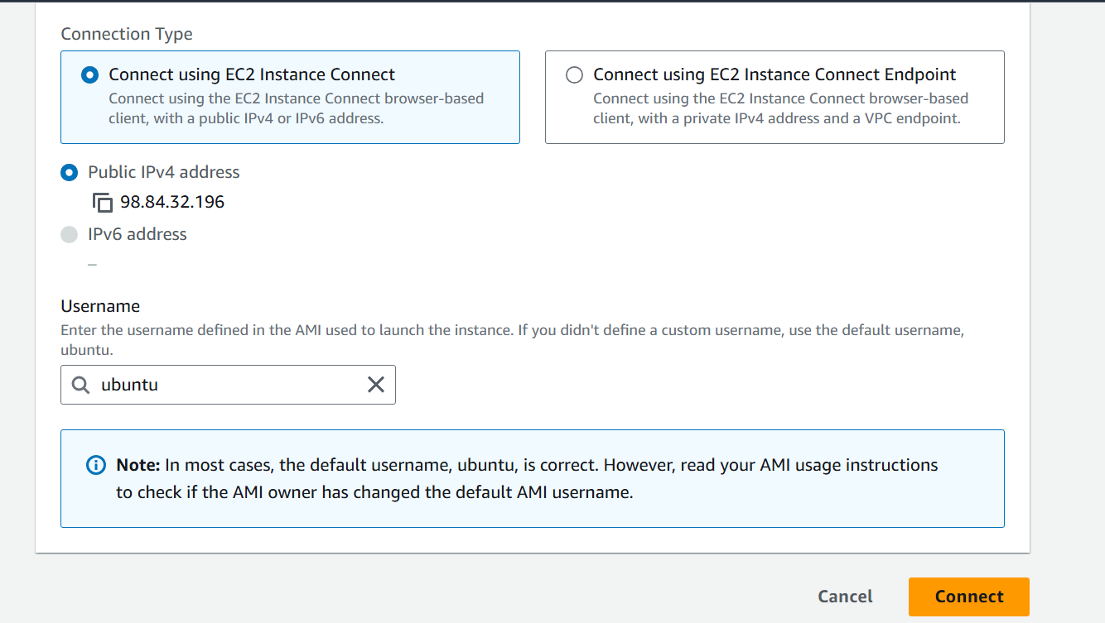

3) Run the following commands

a. sudo su

b. apt update

4) **Setup Docker ,Terraform ,aws cli , and Kubectl**

1. **apt install docker.io**



2. **usermod -aG docker $USER** # Replace with your username e.g ‘ubuntu’

3. **newgrp docker**

5) We will now setup terraform in the machine

wget -O- https://apt.releases.hashicorp.com/gpg | sudo gpg --dearmor -o /usr/share/keyrings/hashicorp-archive-keyring.gpg

echo "deb [signed-by=/usr/share/keyrings/hashicorp-archive-keyring.gpg] https://apt.releases.hashicorp.com $(lsb_release -cs) main" | sudo tee /etc/apt/sources.list.d/hashicorp.list

sudo apt update && sudo apt install terraform

6) Now we will setup the AWS CL

curl "https://awscli.amazonaws.com/awscli-exe-linux-x86_64.zip" -o "awscliv2.zip"

apt install unzip -y

unzip awscliv2.zip

sudo ./aws/install

7) Now we will setup Kubectl

1. sudo apt install curl -y
2. curl -LO <https://dl.k8s.io/release/$(curl> -L -s <https://dl.k8s.io/release/stable.txt)/bin/linux/amd64/kubectl>
3. sudo install -o root -g root -m 0755 kubectl /usr/local/bin/kubectl

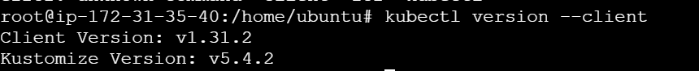

**8) Every thing is setup and installed let’s make a IAM EC2 Role**

Go to IAM -> Roles

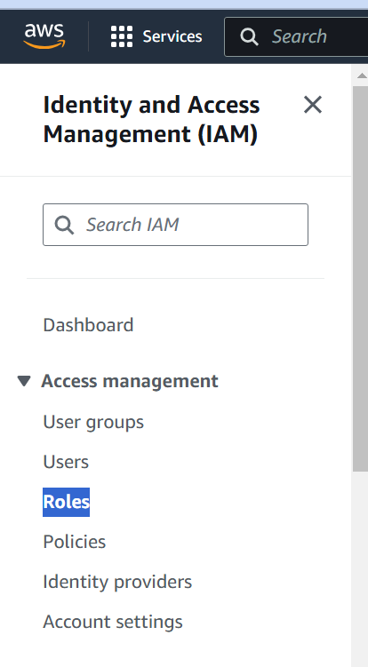

click on create role and choose EC2 from the dropdown

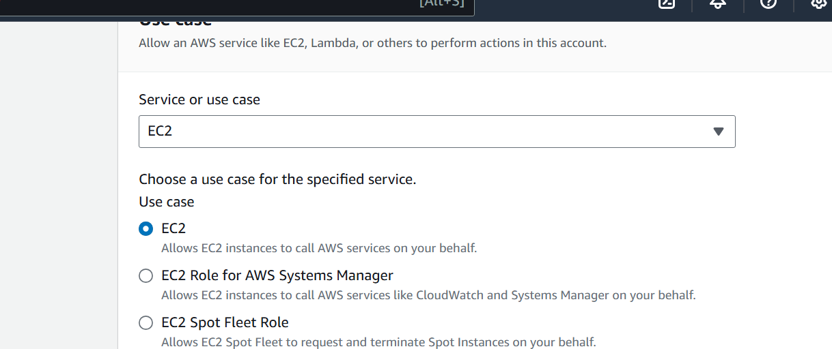

Choose administrator access

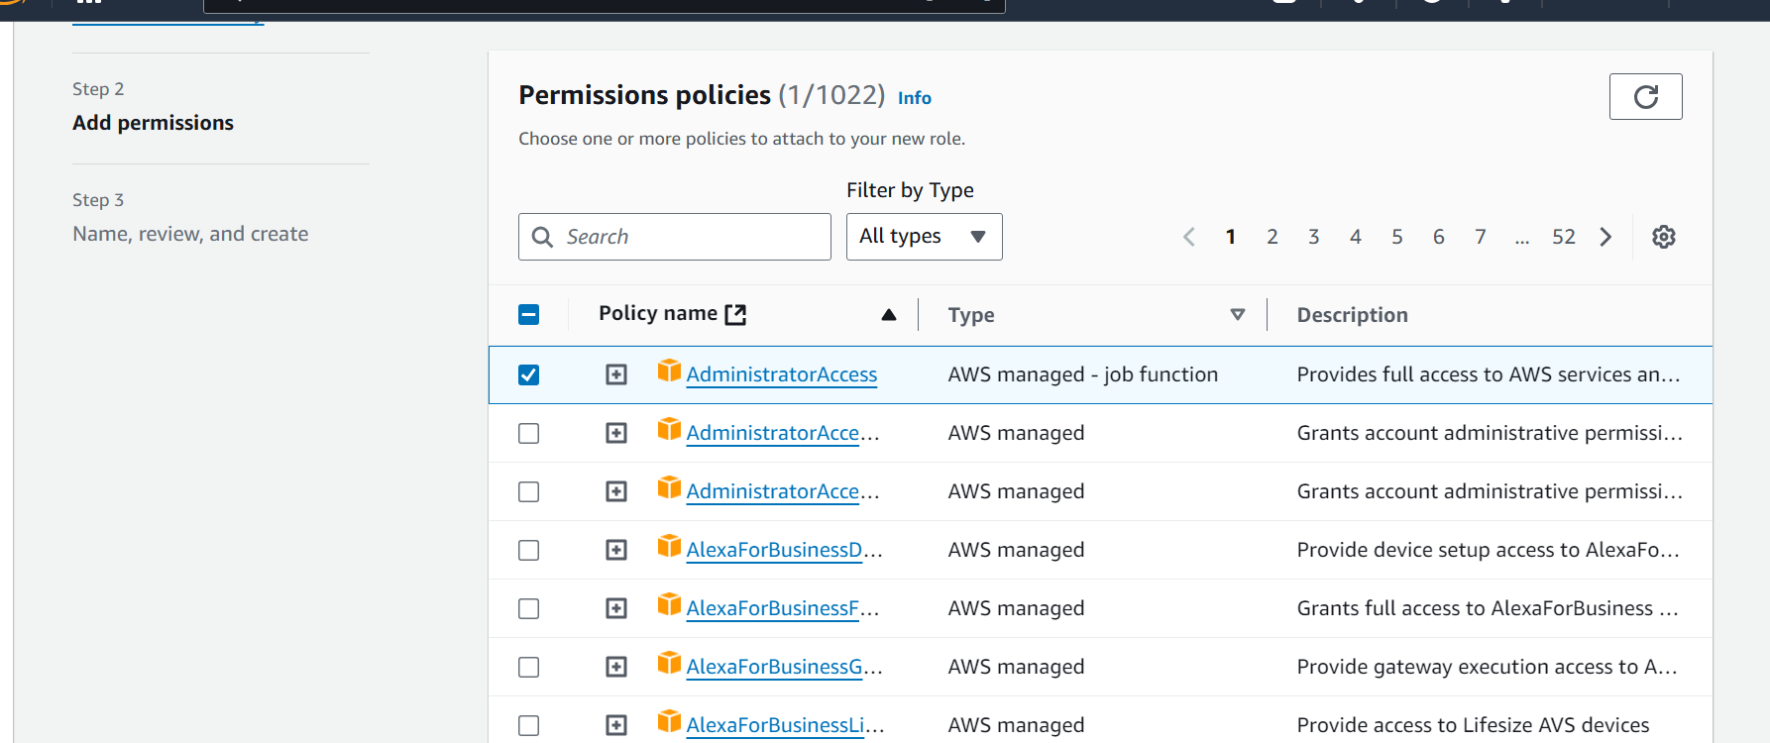

Next

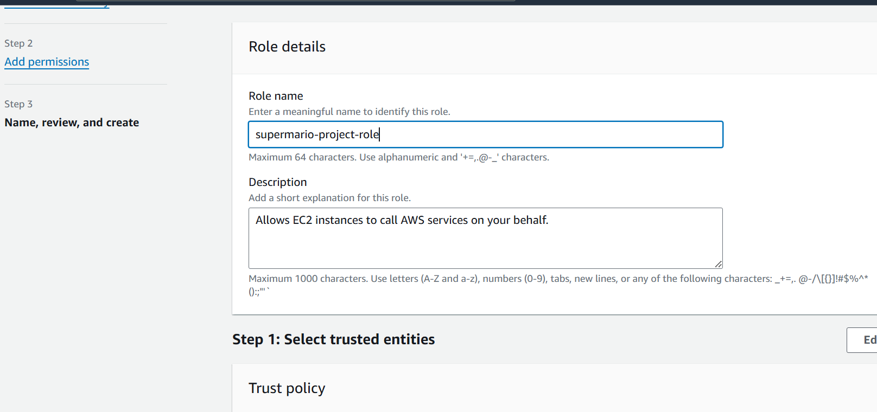

Click on Create role

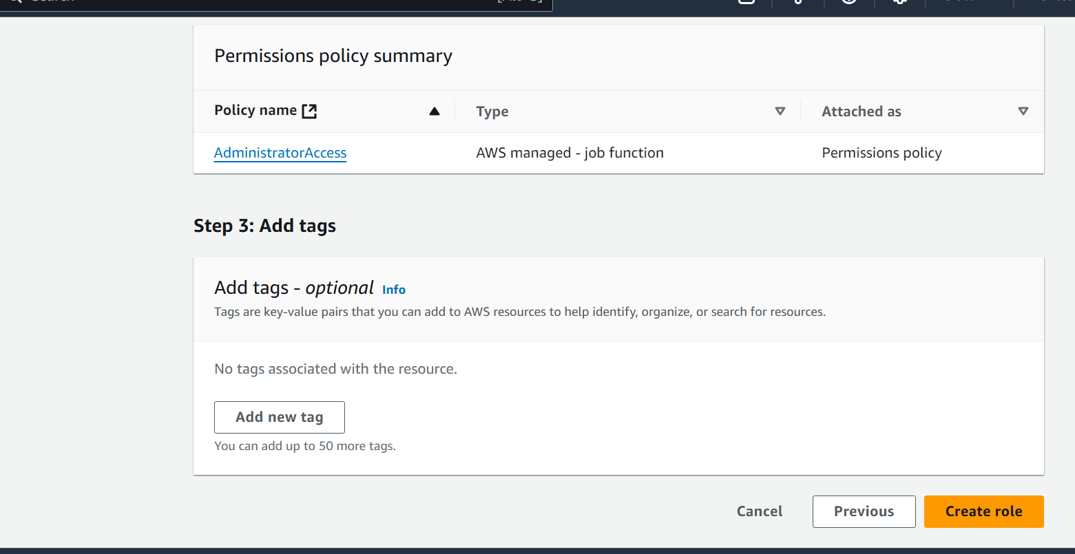

9) Now we will attach the IAM role to Ec2 machine

Go to ec2 machine and select the machine

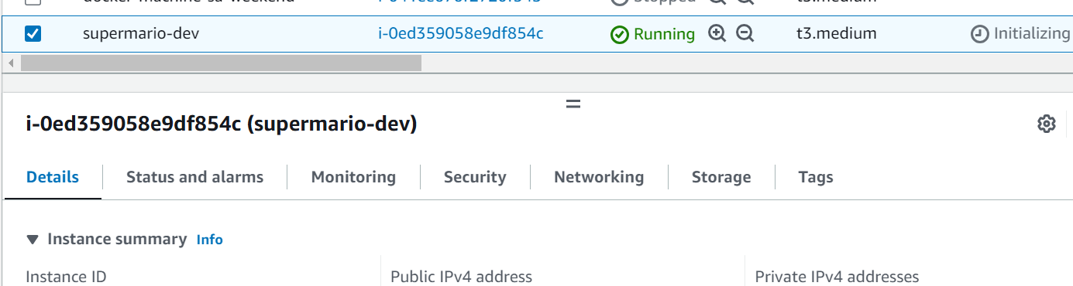

Right click on the machine

Click on Security -> modify IAM role

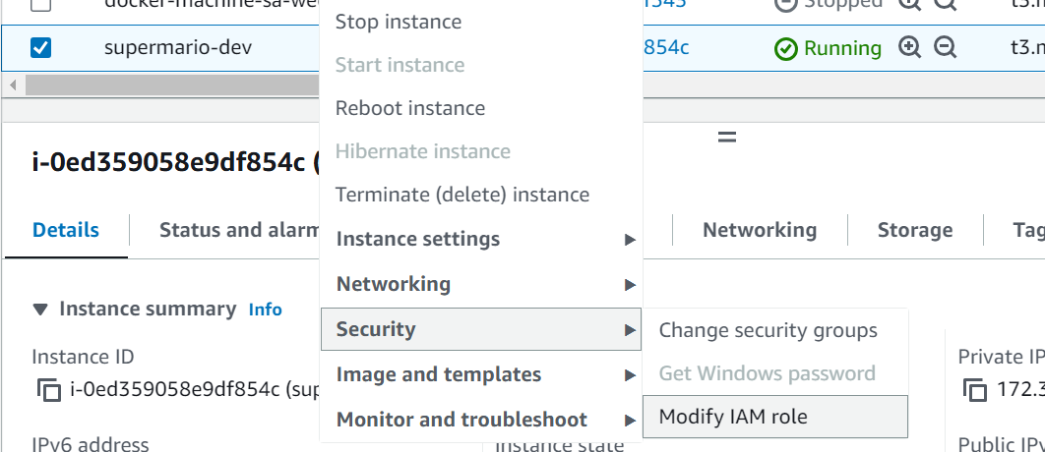

Select IAM role which we created previously

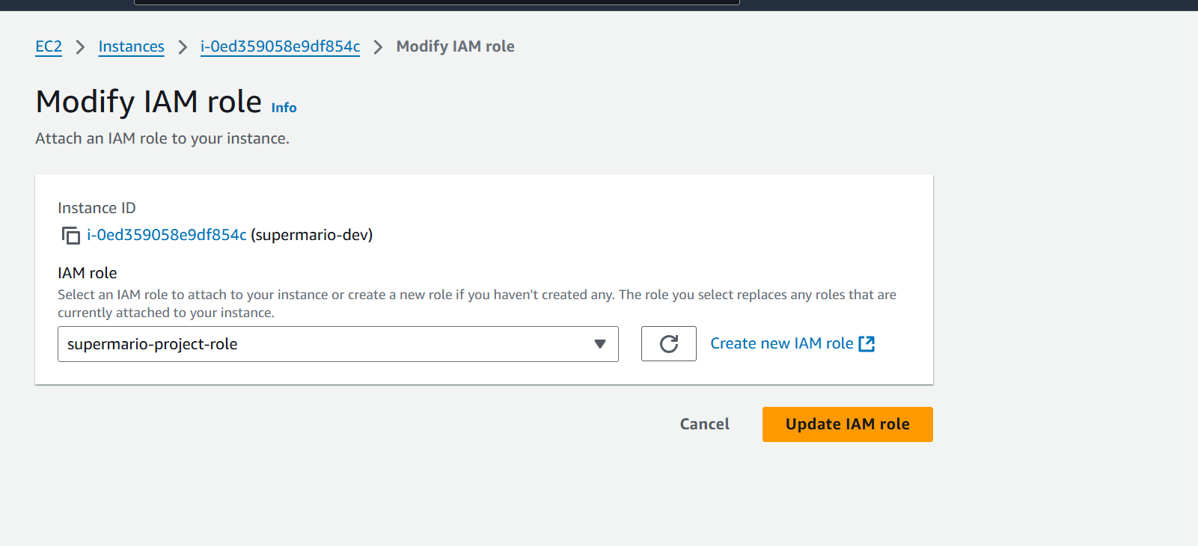

Click on update IAM role

10) **Building Infrastructure Using terraform**

First we will clone the github repo

Go to the machine

mkdir supermario

cd supermario

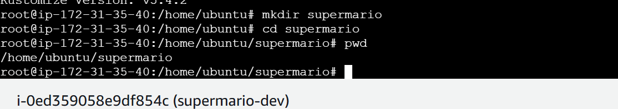

git clone <https://github.com/akshu20791/supermario-game>

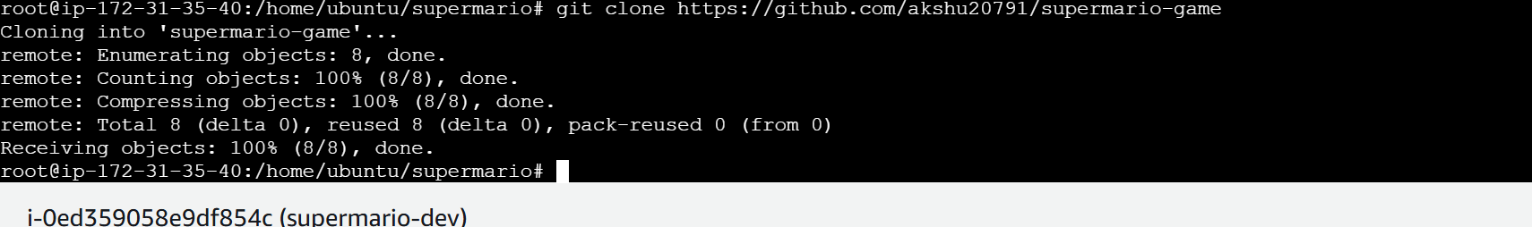



cd supermario-game



**cd EKS-TF**

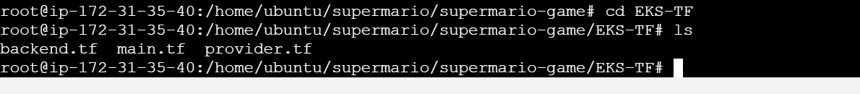

12) Go to aws -> S3 -> Create a s3 bucket with some unique name

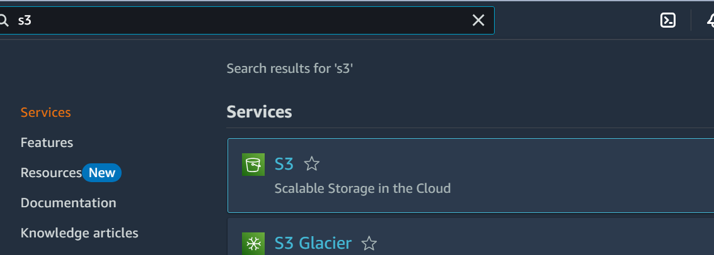

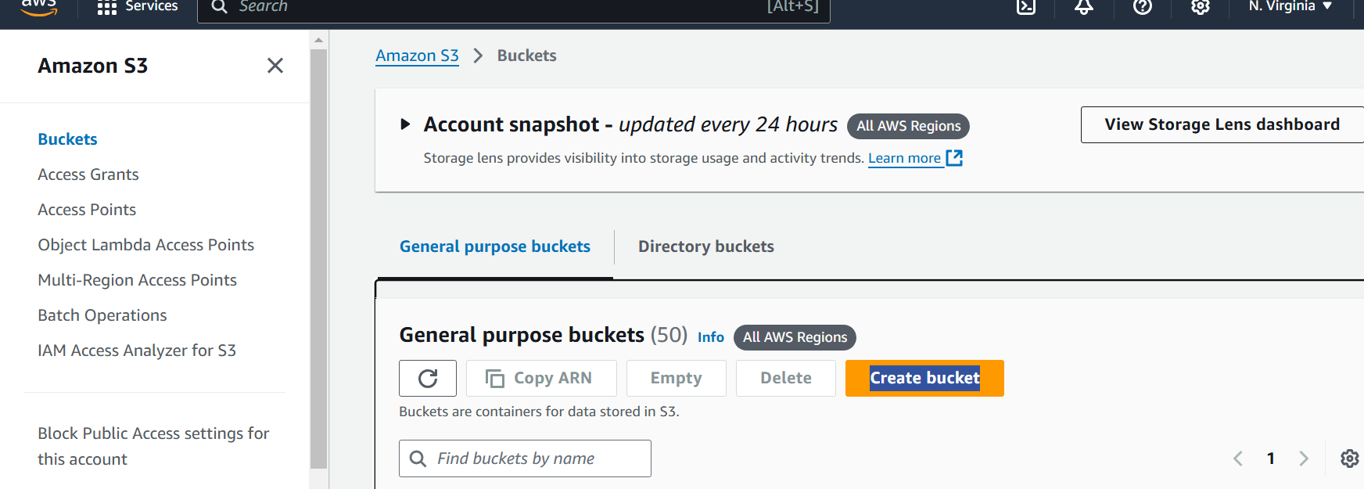

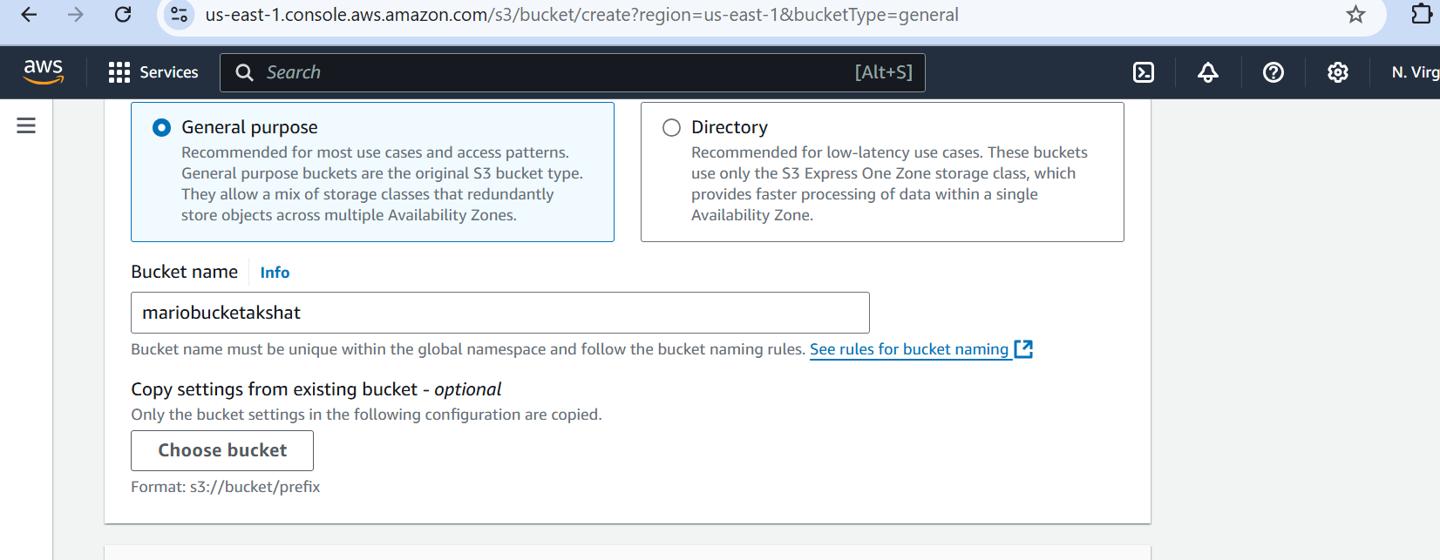

Create bucket

13) Go back to Ec2 machine

edit the backend.tf file by → **vim backend.tf**

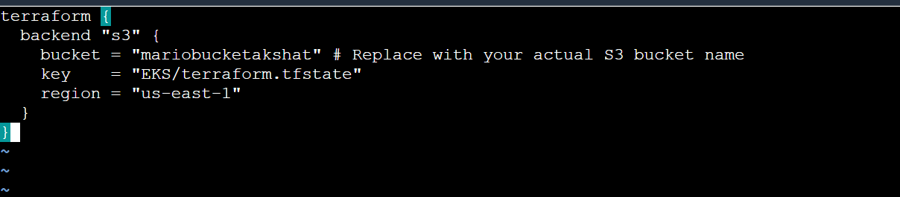

**Note →make sure to provide your bucket and region name in this file otherwise it doesn’t work and IAM role is also associated with your ec2 which helps ec2 to use other services such S3 bucket**

**14) Now we will run**

**terraform init**

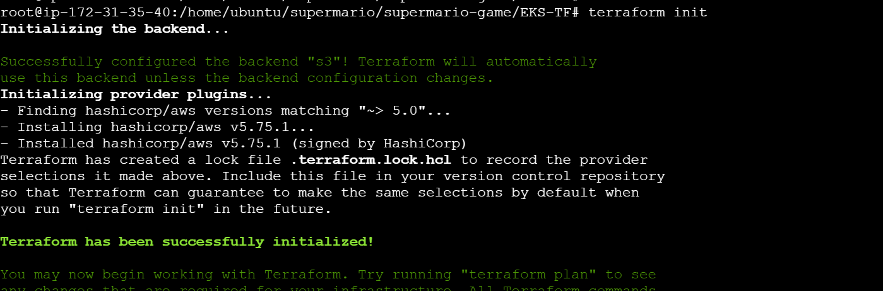

**terraform validate**



Terraform plan

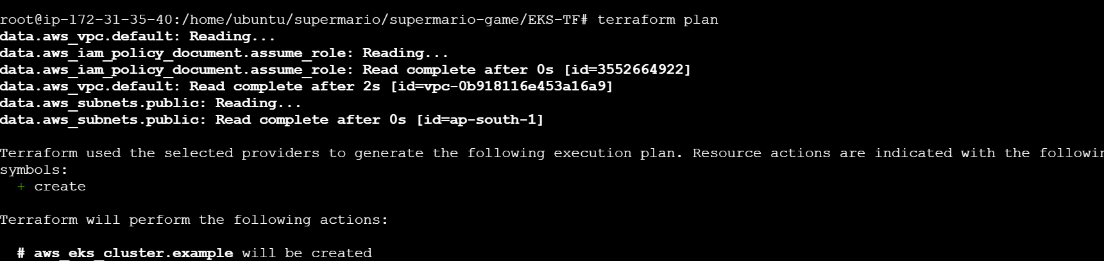

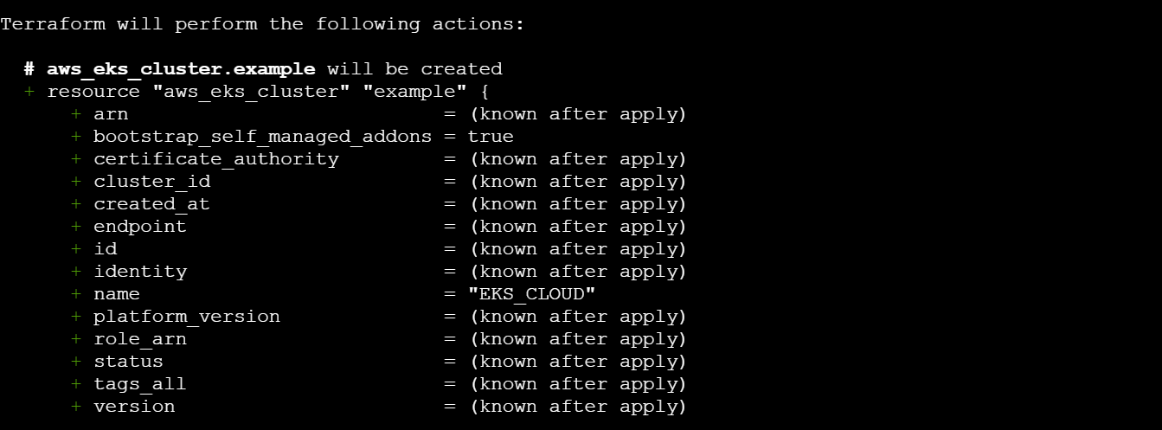

terraform apply --auto-approve

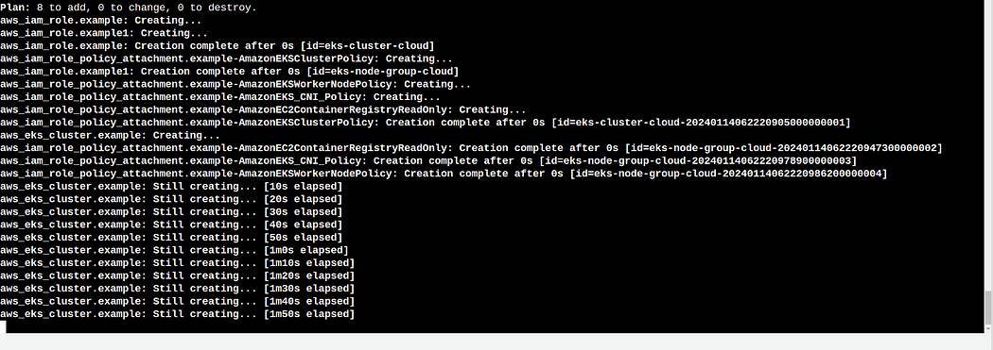

It will take 10-15 minutes to complete 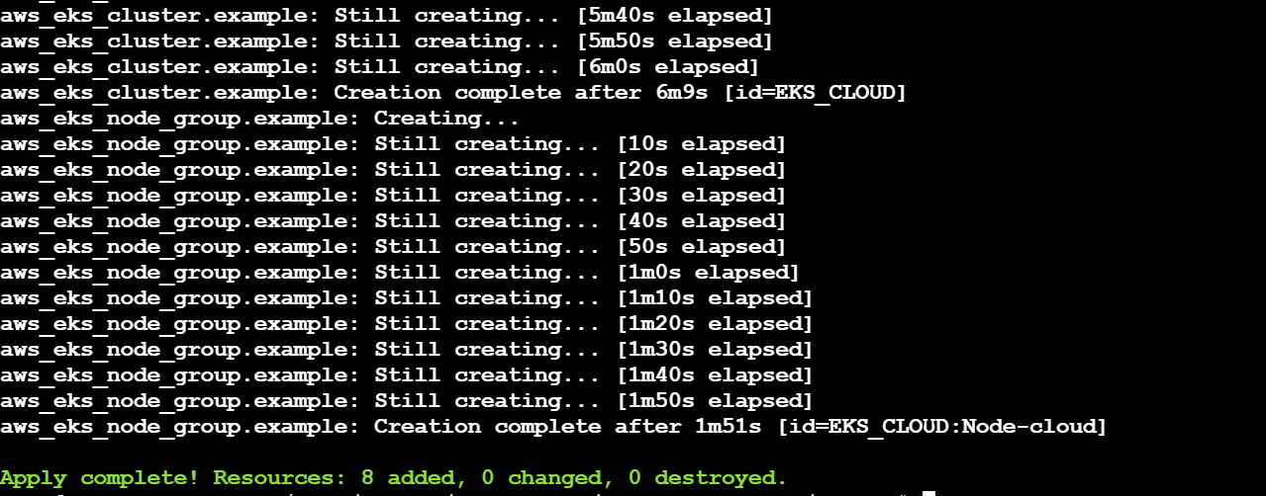

15) Now we will update the configuration of EKS

aws eks update-kubeconfig --name EKS_CLOUD --region ap-south-1

# ensure that you take care of the region you are working in



16) **Creation of deployment and service for EKS**

1. change the directory where deployment and service files are stored use the command → **cd ..**



1. create the deployment

kubectl apply -f deployment.yaml



kubectl apply -f service.yaml



run → kubectl get all

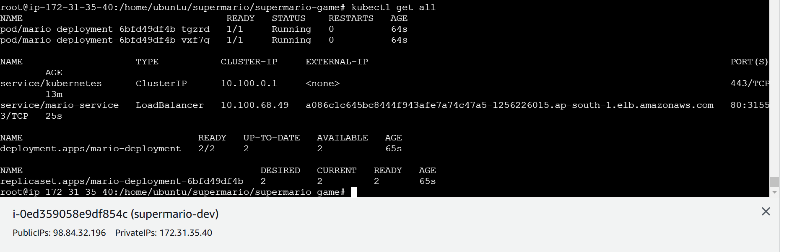

16) Now Run the follwing command to get the load balancer ingress

**This command tells all the details of your application**

kubectl describe service mario-service

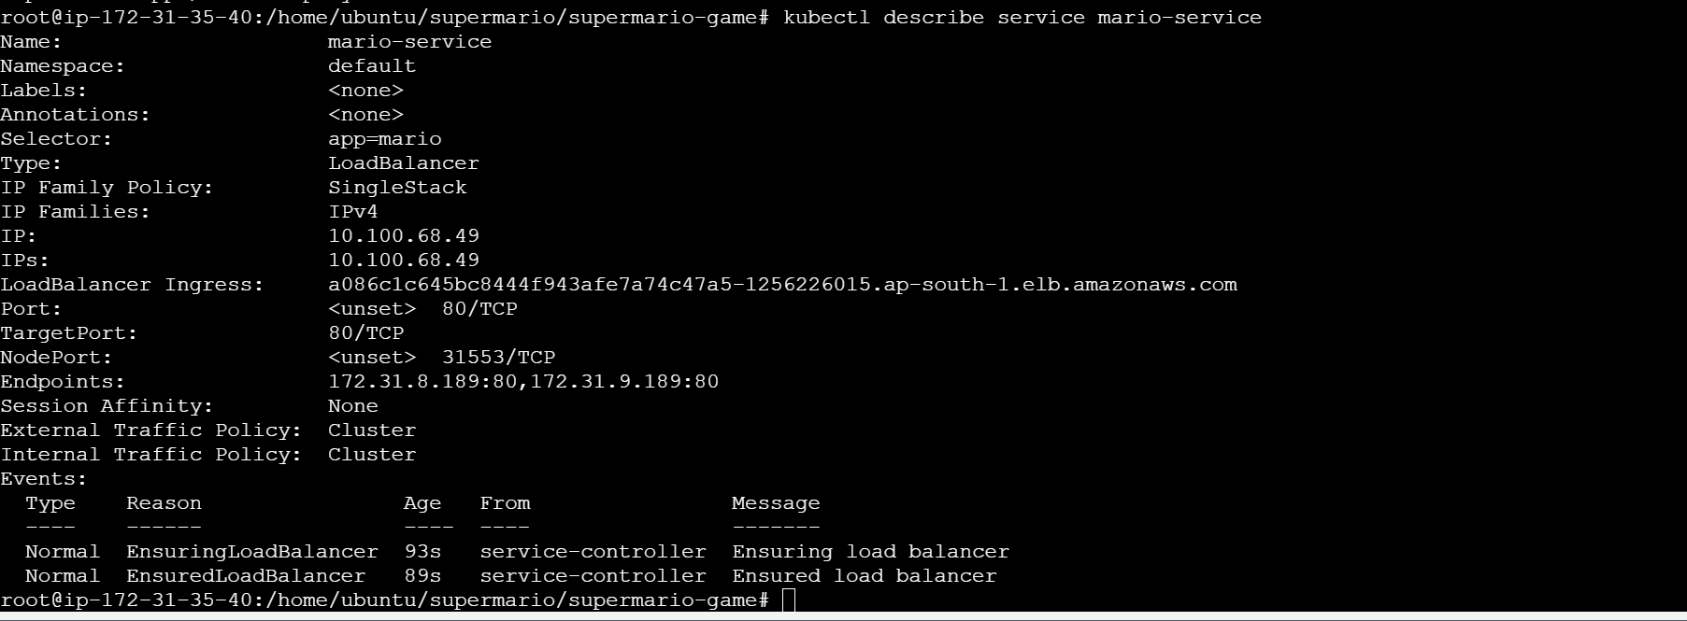

Here you will see load balancer ingress link

Copy that

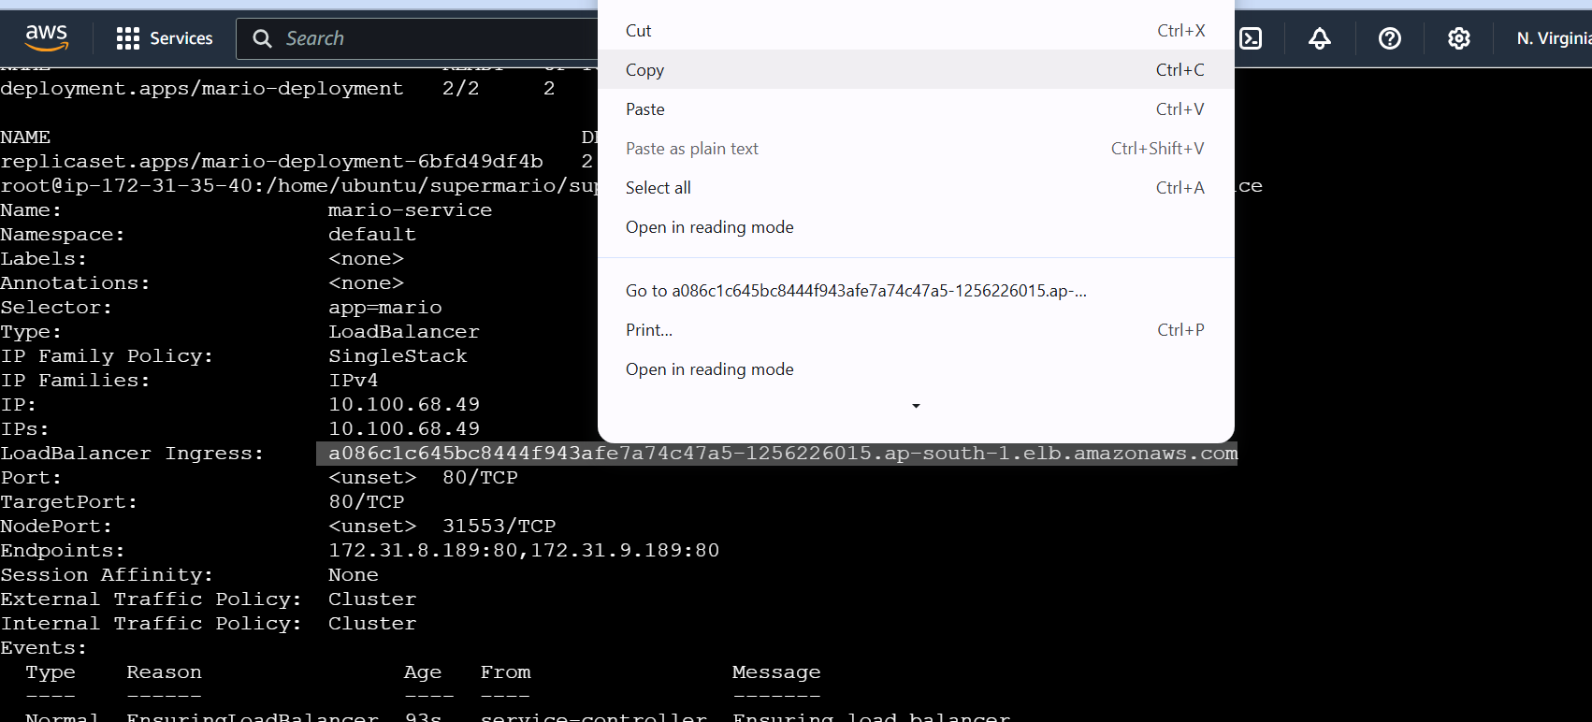

17) paste it in the browser

Ensure that when you copy paste …it should be http not https

